**Yarmouk University**

**Hijjawi Faculty for Engineering Technology Department of Computer Engineering**

**CPE**5**98 - Graduation Project** 2

Smart Car Parking System

**Ro’ya Ali Al–shboul 2018980140 Fatima Ziad Al – shboul 2018980141 Hadeel Mahmoud Obidat2018980142 Ala’a Khaled Nsairat 2018980143**

**Prof. Amin Alqudah**

**Semester: Summer 2021/2022 Date: 25 October 2022**

**Students' Property Right Declaration and Anti-Plagiarism Statement**

We hereby declare that the work in this graduation project at Yarmouk University is our own except for quotations and summaries which have been duly acknowledged. This work has not been accepted for any degree and is not concurrently submitted for award of other degrees. It is the sole property of Yarmouk University and it is protected under the intellectual property right laws and conventions.

We hereby declare that this report is our own work except from properly referenced quotations and contains no plagiarism.

We have read and understood the school's rules on assessment offences, which are available at Yarmouk University Handbook.

|  |  |  |
| --- | --- | --- |
| **Students:** | |  |
| Name: Ro’ya Al–shboul | Signature: | Date: 4th June, 2022 |
| Name: Fatima Al – shboul | Signature: | Date: 4th June, 2022 |
| Name: Hadeel Obidat | Signature: | Date: 4th June, 2022 |
| Name: Ala’a Nsairat | Signature: | Date: 4th June, 2022 |

# Abstract

Parking spaces are extremely important in our lives as we need to find a place to park our cars in almost everywhere we go especially when it comes to emergency, rush or crowded situations then we need to be able to find parking place in very short time hence in this project we implemented a smart car parking system that can be used in any facility like hospitals, malls, universities, etc. to assist drivers to find vacant spaces in car parking place in easy and time-saving way.

The proposed system divides the whole parking facility into smaller levels where each level can occupy certain number of cars and at the entrance, the system checks if any available levels are exists and if so it will open the gate and inform the driver on the LCD which levels are available. Then when driver enters selected level, a green light will be blinking above first closest available parking place along with solid green light above each other available parking place, also in case driver missed out the first available parking place, the system itself will help rerouting the driver to nearest available parking place.

Although this project is a prototype and might sound simple but in fact it can be used in vast parking places and it can impact the time and effort that usually taken to find parking place.

***Keywords*** *— IR, Photo-Transistor, Reflective mode, Transmissive mode, PIR, Smart Parking System.*

**Table of Contents**

Abstract i

List of Tables iii

List of Figures iv

Chapter 1: Introduction vi

* 1. Overview vi
  2. Aims and objectives vii

Chapter 2: Background… 8

Chapter 3: Design 9

* 1. Design Overview 9
  2. Design Procedure 18
  3. Design Details 21

Chapter 4: Implementation 22

* 1. Block Diagram of the system 22

4.2 Project Connection 23

4.3 Project Work and Cases 25

4.4 Project Work and Cases 27

Chapter 5: Results and Discussion 28

Chapter 6: Economical, Ethic, and Contemporary Issues 29

Chapter 7: Project Management 31

Chapter 8: Conclusion and Future Work. 33

References 34

# List of Tables

Table 1: IR infrared obstacle avoidance sensor specifications 14

Table 2: Arduino Mega technical specifications 16

Table 3: Project bill of materials 27

Table 4: Project bill of materials 29

Table 5 : Project timeline 31

# List of Figures

Figure 1: Simple two dimensional diagram for one parking level vii

Figure 2: Common Ultrasonic sensor 10

Figure 3: Common PIR motion sensor 10

Figure 4: Common IR LED 11

Figure 5: Common phototransistor 12

Figure 6: IR reflective mode illustration 12

Figure 7: IR transmissive mode illustration 13

Figure 8: IR reflective mode illustration 13

Figure 9: Schematic diagram for IR infrared … 14

Figure 10: Servo motor 14

Figure 11: Common 16 X 2 LCD 15

Figure 12: Arduino Mega 2560 rev3 development board… 16

Figure 13: Wire 17

Figure 14: Arduino Software 18

Figure 15: Single IR sensor schematic diagram 18

Figure 16: Complete circuit design 20

Figure 17: Block Diagram 22

Figure 18: Connecting the IR sensor with Arduino Mega 23

Figure 19: Connecting the servo motor with Arduino Mega 23

Figure 20: Connecting the LED with Arduino Mega 24

Figure 21: Connecting the LED with Arduino Mega 24

Figure 22: Servo and LCD 25

Figure 23: Go right 25

Figure 24: Go left 25

Figure 25: Go to park1 26

Figure 26: Go to park2 26

Figure 27: Go to park2 26

Figure 28: Go to park3 26

# Chapter 1: Introduction

## Overview

Searching for a vacant parking space for our cars is the daily concern for most drivers, and it is time-consuming and It commonly leads to more traffic congestion especially in emergency situations where time is important factor and in general where we just want to find vacant parking place in our work location for example.[1]

In this project, a smart parking system or smart parking guidance will be implemented where a display at the entrance of the parking will show the drivers which levels of the parking are available and if so it will open the gate then once driver enters certain level he will be guided to the appropriate position by illuminated arrows.

The current smart parking or parking guidance systems only obtain the availability information of parking spaces from deployed sensor networks, and simply publish the parking information to direct drivers.

The smart system will re calculate the closest available place if the driver entered or did not wanted to park in first parking place that he was shown to.

Our proposed smart parking system detection is based on optical sensor particularly Infrared LED (IR) and photo-transistor. We used the IR sensor for reasons that will be mentioned in proceeding chapters. Figure 1 represents simple two dimensional diagram for one parking level.

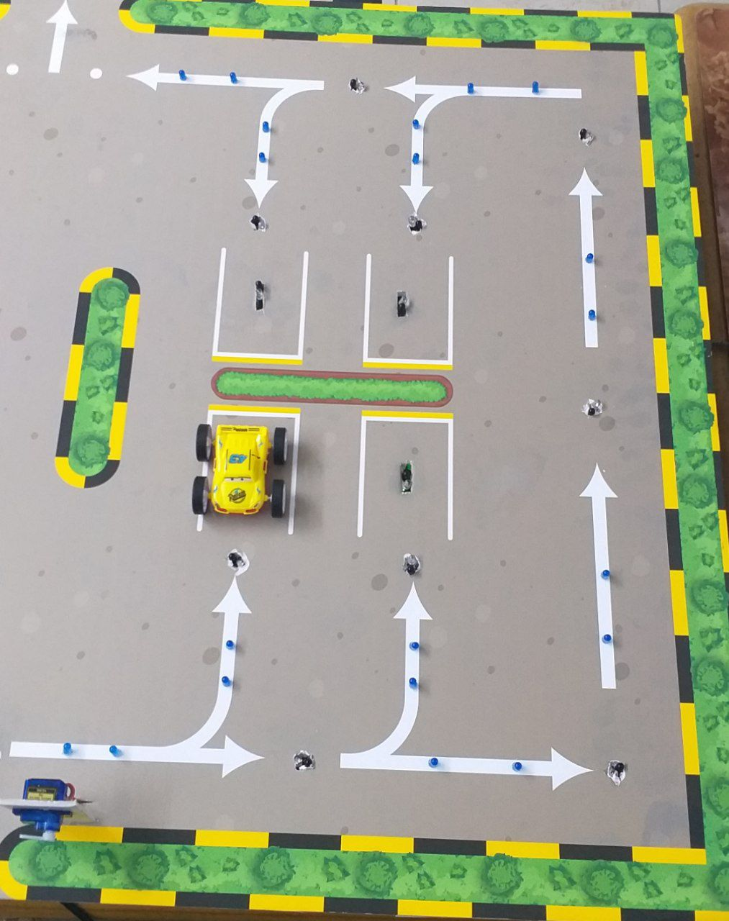

Fig 1: Simple two dimensional diagram for one parking level

Where cars can enter at entrance point if there is any available parking place then based on sensors output signal , a full route to the nearest available parking will be illuminated and in case the driver loses to the nearest point or if you want to choose another place, he will be guided to the second nearest Car parking and first lane off.

## Aims and objectives.

Our project aims to facilitate the car parking process for users by finding a suitable parking in the shortest time and the nearest way. This can be achieved by organizing the movement of cars to reach the nearest empty car park by lighting the path drawn on the ground.

# Chapter 2: Background

The rapid production of vehicles and their usage in recent years has led to a severe issue of finding vacant parking spaces, and this issue occurs particularly in modern cities. This significant problem worsens, especially during peak hours and on weekends. Therefore, developing a car parking management system will assist drivers in finding a suitable parking place for their vehicles.[5].

Many ideas had came up to implement smart parking systems, some of which are mentioned in references and they’re all based on ultrasonic sensors where on contrast we used IR sensors as we believe it will be much effective and reliable for such smart system. We also added the idea of ​​an organized, clear and illuminated path that guides the driver to the appropriate parking.

Any smart car parking system should address at least these features :

* + - Optimized parking : Users should be able to find the best spot available

hence saving time, resources and effort. Also the parking places should fills up efficiently.

* + - Simple interfacing: Users should be able to easily interface with such

smart system in means of displaying messages, light indicating techniques and in some cases cloud applications can take place.

* + - Reduced traffic : Traffic flow increases as fewer cars are required to drive around in search of an open parking space.
    - Reduced pollution :Searching for parking burns around one million barrels of

oil a day!. An optimal parking solution will significantly decrease driving time, thus lowering the amount of daily vehicle emissions and ultimately reducing the global environmental footprint.

# Chapter 3: Design

## Design Overview

After our studying and and researching the practical solutions to implement a smart parking system  
 We decided to use the infrared detection mechanism to detect the availability of the car in the parking spaces and the directing mechanism by putting illuminated arrows on the ground pointing to every single parking space we have in the garage.

The illuminated arrow will light once the sensor on the entrance senses the presence of an object. Meanwhile the gate at the entrance will open only if there is an empty space in the garage and the LCD will display a directive message indicating the direction the car should go through. if the first parking space was occupied the illuminated arrow pointing on it will be turned off and the arrow pointing to the second parking space will be turned on and so on once the parking space is occupied the arrow pointing at it will be turned off and immediately, the next arrow pointing at the next parking space will be turned on till the point where every parking space in the garage is occupied.

In the case if the driver did not commit to the path we made and choose a random spot to park at the system itself will reroute the path and light the arrows to the next parking place considering our main goal by choosing the nearest parking spot in the shortest time.

There are two main alternatives to IR sensor which can be used in smart parking systems which they are

* + - Ultrasonic Sensor
    - PIR Motion Detector Sensor

The Ultrasonic sensors have long been used for range measurements, tank level control, and web brake and proximity detection in difficult environments, challenging reflection surfaces or when the need for extreme accuracy that traditional optical sensors can not provide. The common ultrasonic sensor is shown in Fig.2.[1,4].

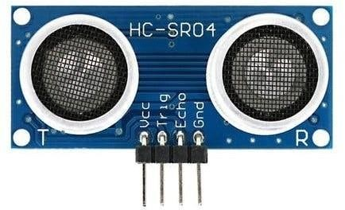

Fig 2: Common Ultrasonic sensor

On the second hand the PIR motion sensors allow you to sense motion, it’s used to detect whether an object has moved in or out of the sensors range. They are often referred to as PIR (Passive Infrared). A common type is shown in Fig.3.

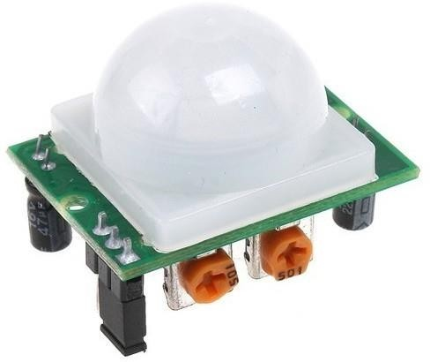

Fig 3: Common PIR motion sensor

The advantages of PIR motion sensors is that they are small, inexpensive, low-power, easy to use and don't wear out but due to the fact that any movement can trigger a signal we can not use them. For instance a Cat walking in parking space or a Human do will trigger a motion detection action hence a false data can be sent back to microcontroller.

We could have used the Ultrasonic sensor as other proposed smart parking systems did but since all we need is to effectively know if a car is present in parking place or not and measuring distance is not our concern hence we used a pair of IR LED and photo detector to build a single sensor. In this way we saved the overall cost dramatically as pair of IR sensor is much less in cost than Ultrasonic sensor and much easier to control as we only need to monitor a change in digital output signal ( 1 = car not present, 0 = car is present).

From now on we will focus on IR sensor as it will be the main sensing mechanism in our project.

An infrared LED is shown in Fig.4. it’s the most common IR LED that usually used in Free air transmission system, remote control units, smoke detectors and Infrared applied system. It’s main features are High reliability, High radiant intensity and Low forward voltage.[2].

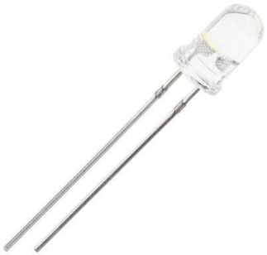

Fig 4: Common IR LED

The other part is the photodetector (phototransistor) that used to detect IR light. Common phototransistor are shown in Fig.5. it has a fast response time, high photo sensitivity and low power.[2].

It can be considered as normal BJT transistor except that the base excitation is done thought incident IR light.

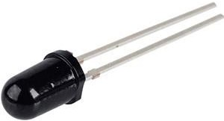

Fig 5: Common phototransistor

Two modes are commonly used with IR sensors, Reflective mode and Transmissive mode.

In reflective mode the IR LED and phototransistor are placed next to each-other and sensing is done based on reflected IR light from body to phototransistor as illustrated in Fig.6.[6]

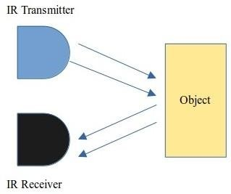

Fig 6: IR reflective mode illustration

in transmissive mode, the IR LED and phototransistor are right in front of each-other and sensing is done based on crossing the IR light that being transmitted from IR LED to phototransistor. An illustration is shown in Fig.7.[6].

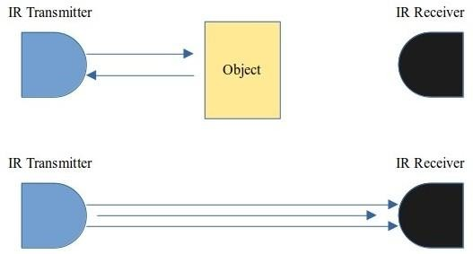

Fig 7: IR transmissive mode illustration

Two modes are commonly used with IR sensors, Reflective mode and Transmissive mode.

Through this project we will use the since IR infrared obstacle avoidance sensor its commercially available as single unit called IR infrared obstacle avoidance sensor ,shown in Fig 8.

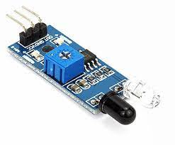 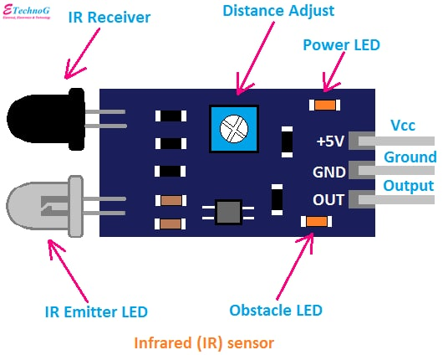

Fig 8: IR infrared obstacle avoidance sensor

Table1: IR infrared obstacle avoidance sensor specifications

|  |  |
| --- | --- |
| **Pin, Control Indicator** | **Description** |
| VCC | 3.3 to 5 Vdc Supply Input |
| GND | Ground Input |
| OUT | Output that goes low when obstacle is in range |
| Power LED | Illuminates when power is applied |
| Obstacle LED | Illuminates when obstacle is detected |
| Distance Adjust | Adjust detection distance. CCW decreases distance |
| IR Emitter | CW increases distance. |
| IR Receiver | Infrared emitter LED |

The IR Sensor consists of an Infrared Transmitter, an Infrared Detector, and support circuitry. It only requires three connections. When it detects an obstacle within range it will send an output low.

Through Furthermore, the IR sensor is easy to assemble, easy to use features, can be widely used in robot obstacle avoidance, avoidance car, line count, and black and white line tracking and many other occasions.

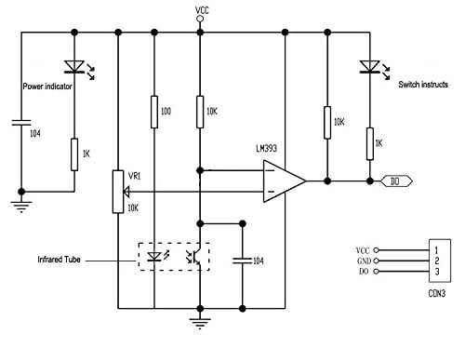

Fig 9 : Schematic diagram for IR infrared

For controlling the gate we used small servo motor as this one shown in Fig.10

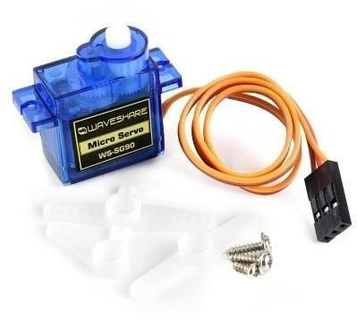

Fig 10: Servo motor

Servo motor is a device that converts an electrical signal into a mechanical movement. This motor differs from direct current (DC) motors in that Its movement is not continuous.

When an electrical signal enters the servo motor with a certain value, this causes it to move at a certain angle, then the motor stops moving and remains Keep the angle he got to, Unlike DC motors, they continue to rotate once they are supplied with electric current.

The servo motor works by adjusting the electrical PWM signal with a specific time. The Arduino hardware library takes care of this, and depending on this signal the servo moves at a certain angle from 0 to 180 degrees.

For showing the drivers info about the vacancy inside parking levels, we will use a common 16 X 2 LCD as shown in Fig.11.

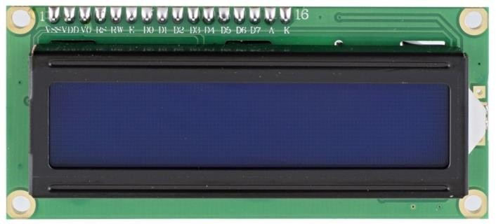

Fig 11: Common 16 X 2 LCD

A 16x2 LCD means it can display 16 characters per line and there are 2 such lines. In this LCD each character is displayed in 5x7 pixel matrix. The 16 x 2 intelligent alphanumeric dot matrix display is capable of displaying 224 different characters and symbols.

Finally to control all these sensors, actuators and interface we need a microcontroller where the best choice was the Arduino Mega which is complete development board containing all required external components needed for main microcontroller to function, also it contains connector headers, power unit, USB port to communicate with PC. The Arduino Mega board is shown in Fig.12.

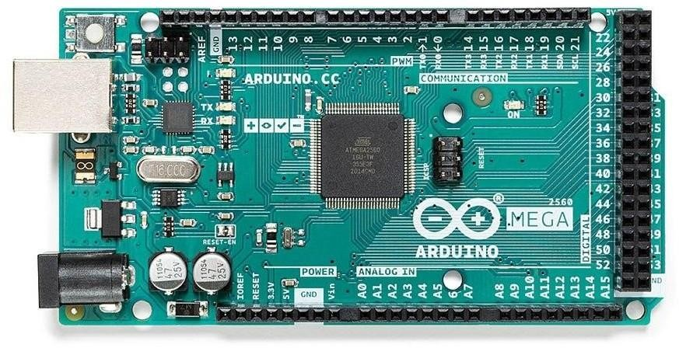

Fig 12: Arduino Mega 2560 rev3 development board

The Arduino Mega 2560 is a microcontroller board based on the ATmega2560. It has 54 digital input/output pins (of which 15 can be used as PWM outputs), 16 analog inputs, 4 UARTs (hardware serial ports), a 16 MHz crystal oscillator, a USB connection, a power jack, an ICSP header, and a reset button. It contains everything needed to support the microcontroller and it can be programmed by Arduino IDE which is the official open source tool to program various development boards.

Technical specifications for the Arduino Mega are listed in Table.2. it’s important to pay attention to input/output pin capabilities and not to exceed maximum ratings.

Table 2: Arduino Mega technical specifications

|  |  |
| --- | --- |
| **Specification** | **Value** |
| Microcontroller Chip | ATmega2560 |
| I/O Operating Voltage | 5V |
| Input Power Voltage (RECOMMENDED) | 7-12V |
| Digital I/O Pins | 54 (of which 15 provide PWM output) |
| Analog Input Pins | 16 |
| DC Current Per I/O Pin | 20 mA |
| DC Current For 3.3V Pin | 50 mA |
| Flash Memory | 256 KB of which 8 KB used by bootloader |
| SRAM | 8 KB |
| EEPROM | 4 KB |
| Clock Speed | 16 MHz |
| LED_BUILTIN_IO_NUM | 13 |
| Physical Length | 101.52 mm |
| Physical Width | 53.3 mm |

A wire is a single, usually cylindrical, flexible strand or rod of metal. Wires are used to bear mechanical loads or electricity and telecommunications signals. Wire is commonly formed by drawing the metal through a hole in a die or draw plate. Wire gauges come in various standard sizes, as expressed in terms of a gauge number. The term wire is also used more loosely to refer to a bundle of such strands, as in "multistranded wire", which is more correctly termed a wire rope in mechanics, or a cable in electricity.

Wire comes in solid core, stranded, or braided forms. Although usually circular in cross-section, wire can be made in square, hexagonal, flattened rectangular, or other cross-sections, either for decorative purposes, or for technical purposes such as high-efficiency voice coils in loudspeakers is shown in Fig.13.[5]

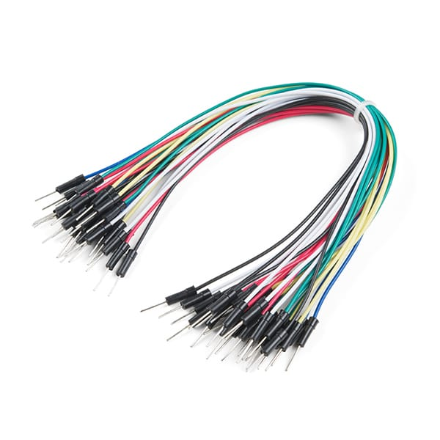

Fig 13: Wire

**Arduino Software**

The open-source Arduino Software (IDE) makes it easy to write code and upload it to the board. It runs on Windows, Mac OS X, and Linux. The environment is written in Java and based on Processing and other open-source software is shown in Fig.14.[9]

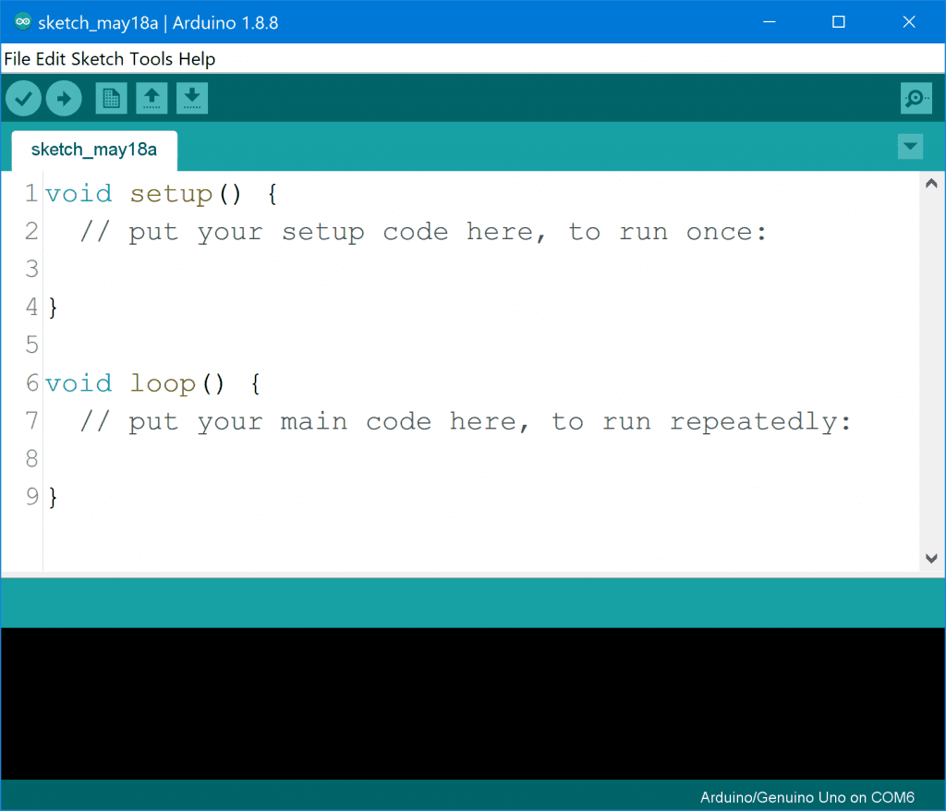

Fig 14: Arduino Software

## Design Procedure

First step is to design the sensor circuit where a simple combination of two resistors with IR LED and phototransistor is used as shown in Fig15.

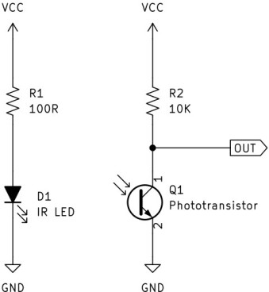

Fig 15: Single IR sensor schematic diagram

As this project is a prototype we choose to make 2 levels inside the parking with 4 parking places in each level hence we need a 16 independent sensor and one extra sensor to control the main gate to open when car arrives. Servo motor to open/ close the gate and finally LCD at the gate.

The complete circuit design is shown in Fig.16. The circuit drawn using KiCad software as it has all libraries for used components and for the reason that we might design a PCB layout using KiCad in case we decided to implement all electronic components on single PCB.

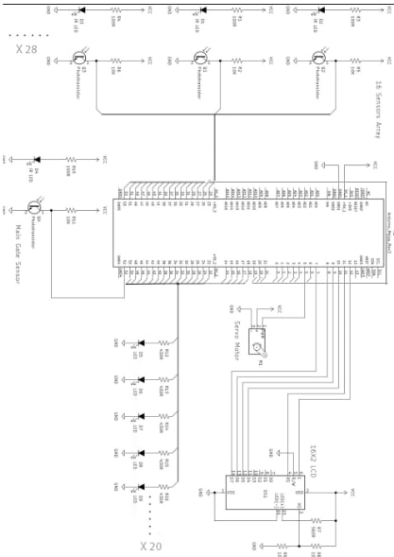

Fig 16: Complete circuit design

**3.3 Design Details**

**3.3.1 Legal Aspects**

There is no breach legally.

**3.3.2 Design Standards**

We have adhered to the standards of The Institute of Electrical and Electronics Engineers, Inc. (IEEE) creates international standards for telecommunications, information technology and power generation.

**3.3.3 Design Alternatives**

This design can be used as a reference for the development of this project by adding a camera and dispensing with the huge number of sensors and thus

The total cost of large volume parking is reduced.

One of the alternatives we have considered is to use a toggle switch in every situation and dispense with the IR sensor due to its low cost.

**3.3.4 Design Safety**

Certain safe equipment will be used in the construction of the project, and no harmful materials will be used in the situations. Protection will be placed on the devices that will be used in the construction of the project, and protection will be placed to reduce the rate of collision between cars inside car parks, in addition to not placing sharp objects in the device body.

**3.3.5 Design Constraint**

Obstacles and problems encountered during the preparation of the project

Due to the large size of the design, we had problems with the large number of tools we needed to cover the needs of two areas and eight parking spaces of sensors, lights, wires, etc. and other parts we needed for the project to work perfectly.

Also, this huge number of used parts put great stress on the Arduino Mega causing it to burn out, so we had to replace it with new ones, which increased the project cost and a loss of time.

# Chapter 4: Implementation

Our project consists of two levels, each level contains 4 parking spaces,We decided to use the infrared detection mechanism to detect the availability of the vehicle in the parking spaces and the steering mechanism by placing illuminated arrows on the ground indicating each parking spot we have in the parking lot. There is a gate at the entrance that opens only if there is an empty space in either level A or B, and the LCD will display an indicative message indicating the direction the vehicle should go in and the number of empty parking spaces within the car park.

The arrow will light up as soon as the sensor on the entrance senses the presence of something. Meanwhile, if the first parking space is occupied, the luminous arrow pointing to it will turn off, the arrow pointing to the second parking space and so on, once the parking space is occupied, the arrow pointing to it will immediately turn on, it will be turned on . The next arrow indicates the next parking spot.

**4.1 Block Diagram of the system**

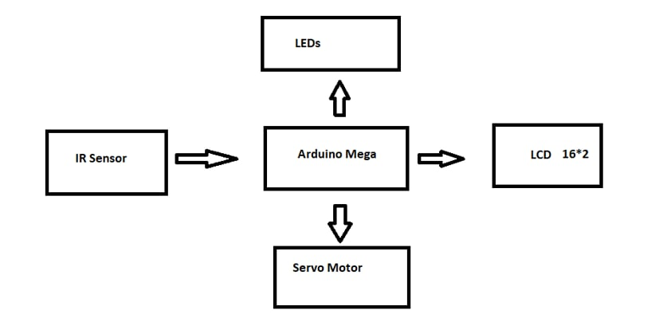

Fig 17: Block Diagram

## Project Connections :

## Connecting the IR sensor with Arduino Mega:

As shown in Fig 18 below, we need three connections to IR sensor: voltage, ground and data.

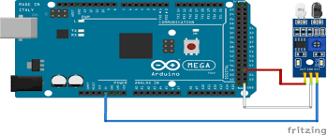

Fig 18: Connecting the IR sensor with Arduino Mega

### Connecting the Servo motor with Arduino Mega:

As shown in Fig 19 below, we need three connections to servo motor : the red color is 5v, the color is black or brown for GND, and the color orange or yellow is connected to digital pin 9.

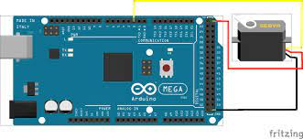

Fig 19: Connecting the servo motor with Arduino Mega

### Connecting the LED with Arduino Mega:

As shown in Fig 20 below, To connect an LED to Arduino Mega we need a breadboard an LED, wires, a resistor, and an Arduino Mega .We start by connecting the ground pin with the cathode (negative part of the LED) using a wire then we connect a digital pin to the resistor that is connected to the Anode (the positive part of the LED) and by putting the suitable code the LED will turn on.

.

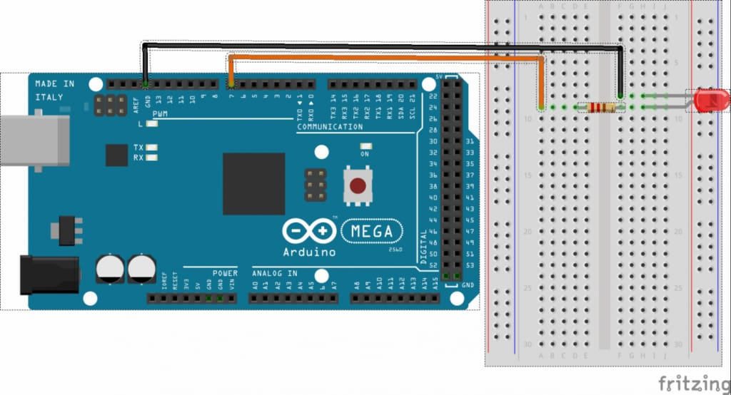

Fig 20: Connecting the LED with Arduino Mega

### Connecting the LCD with Arduino Mega

As shown in Fig 21 below, we need four connections: GND ,SCL, SDA ,VCC

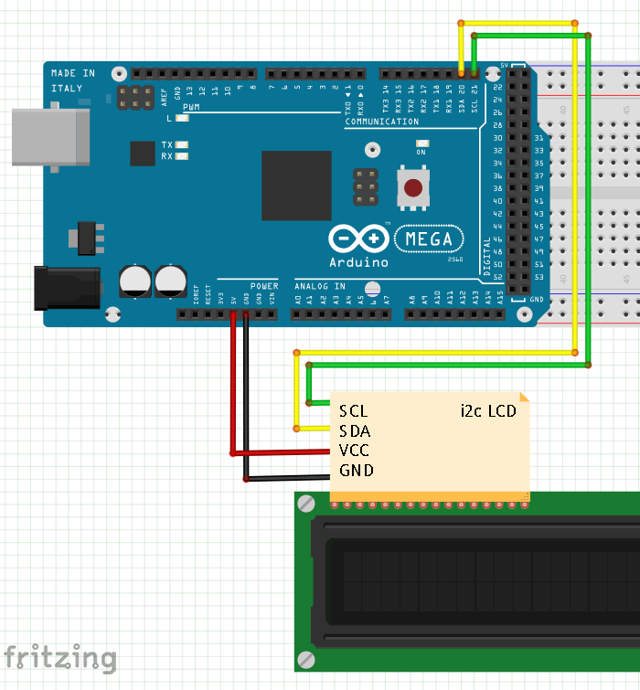

Fig 21: Connecting the LCD with Arduino Mega

## 4.3 Project Work and Cases:

Our project contains two levels, each level contains four parking.

**4.3.1 Work outside levels:**

At the entrance gate there will be a servomotor to open and close the gate and the IR sensor is responsible on sensing the arrival of the car, and accordingly, it is checked if there is any empty car park or not If there is an empty car park on both levels, the gate will open and display "go right or left" As shown in Fig 22 .

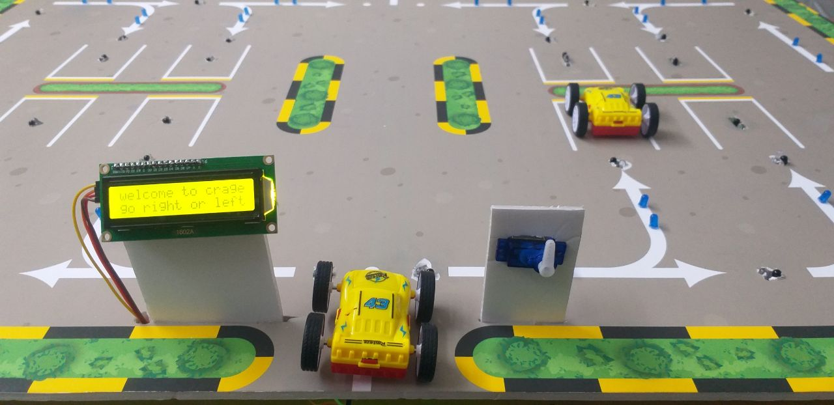

Fig 22: Servo and LCD

else if it is at level A only “go right” will be displayed, but if it is at level B only “go left” will be displayed, In the event that there is no empty parking space in both levels, "sorry the parking full" will be displayed. As shown in Fig 23 and 24.

Fig 23: Go right Fig 24: Go left

After entering the car, the driver will have the freedom to choose the level driver for him.

**4.3.2 Work in each level:**

Based on the idea of ​​our project, the driver will be directed to the nearest car park at the level of his choice, For example if he chooses level A and In the event that parking number 1 is empty As shown in Fig 25, it will be directed to it as it is the closest, but if parking 1 is occupied, it will be directed to parking number 2 based on the order of parking in priority As shown in Fig 26.

# Fig 25: Go to park 1 Fig 26: Go to park 2

In The event that the driver does not adhere to lining up in the first parking to which he was directed, he will be Guide him to the second nearest parking, For example:

Suppose driver is directed to parking 2 as the nearest park, but the driver does not comply with the park for some reason, the system will redirect the driver to parking 3 as it is the second closest park after parking 2. See Fig 27 and 28.

Fig 27: Go to park 2 Fig 28: Go to park 3

## Comparison between Old and New Idea:

Table 3: Comparision

|  |  |  |  |
| --- | --- | --- | --- |
| comparison criteria | Old idea | New idea | Alternative idea |
| Guidance to parking spaces | illuminated LEDs above all parking spaces where the occupied parking spots will have a red LED and the empty one will have a green LED but the nearest parking space will have a blinking green LED. | illuminated arrows pointing at every parking space. | _ |
| cars detection mechanism | IR infrared obstacle avoidance sensor | TCRT5000 IR Sensor | 1-Limited switch  2-using cameras all over the garage instead of sensors and by using image processing properties such as image subtraction the presence of cars can be detected |
| Arduino | Arduino Mega | Arduino Mega | Couple of connected Arduino Uno |
| In case of lack of commitment by the driver | The system itself will change the light order of the LEDs considering the nearest parking space to the driver | The system itself will handle the change and reroute the illuminated path for the car considering the nearest parking space to the driver | _ |

# Chapter 5: Results and Discussion

We expect a car park that will make it easier for the driver to park and reduce the time spent searching for a parking space by directing him to the nearest empty car park, as well as reducing energy consumption by turning off the illuminated arrows behind the car .

# Chapter 6: Economical, Ethic, and Contemporary Issues

* 1. **Preliminary Cost Estimation and Justification**

The purpose of estimating is to determine the forecast costs required to complete a project in accordance with the design plans and specifications. The estimator can produce, within reasonable accuracy, the total costs for a given project. There are two distinct tasks in estimating: to determine the probable real cost and to determine the probable real time to build the project.[8].

Our project contains main two aspects, hardware and software. The software will be written using open source, free tool and will not require any financial cost so we’ll focus on hardware components cost which we tried to estimate based on Table.3

Table 4: Project bill of materials

|  |  |  |
| --- | --- | --- |
| **Value** | **Quantity** | **Estimated Cost (JD)** |
| Arduino Mega Rev3 Development Board | 1 | 18 |
| IR infrared obstacle avoidance sensor | 29 | 90(3 each) |
| 16X2 LCD | 1 | 3 |
| 5V Servo Motor | 1 | 5 |
| 5mm Blue LED | 40 | 5 |
| 9V DC Power Supply | 1 | 3 |
| wires | TBD | 15 |
| Others (to construct the design) | - | 55 |
| **Total** | | **194** |

* 1. **Relevant Codes of Ethics and Moral Frameworks**

According to engineering codes of ethics.[9], the engineer's most important obligation is to ensure the safety, health, and welfare of the public. Although everyone must avoid endangering others, engineers have a special obligation to ensure the safety of the objects that they produce. That’s why in our project we will address all safety aspects and highlight any considerations that must be payed attention in any commercial construction.

* 1. **Relevant Environmental Considerations**

Environment is so important when it comes to cars as toxic substances such as carbon dioxide and carbon monoxide are emitted when fuels such as gasoline and diesel oil are burned in automobiles( non zero-emission cars). These substances cause a variety of environmental problems such as air pollution and global warming, which is why a smart car parking system that help drivers find empty place much quickly will help the impact on environment.

* 1. **Relevance to Jordan and Region (Social, Cultural, and Political)**

In Jordan essentially in capital city Amman , drivers are struggle with traffic jam and finding a parking place is not easy and sometimes takes long time so a solution like our proposed one will impact this issue in Jordan and in any other regions

# Chapter 7: Project Management

* 1. **Schedule and Time Management**

The key to a successful project is good planning. Planning provides the basis for the initiation, implementation and termination of a project. It sets guidelines for specific project objectives and milestones. This activity involves the overall planning, scheduling, and control needed to sequence operations properly and allocate resources effectively. Therefore, it would not be incorrect to claim that scheduling is one of the most essential components of the design and construction phases of a project.[8]

Thus we focused on planning our project by setting up a timeline and make sure to follow on it. Table.4 shows our estimated timeline.

Table 5: Project timeline

|  |  |
| --- | --- |
| **Task name** | **Estimated period** |
| Start designing a project template | 1 week |
| Start preparing project tools | 1 week |
| Background research ( literature review) | 2 weeks |
| Writing introduction, background and review so far work done | 1 week |
| Design (compare alternatives, construct figures, design schematics and test initial circuit design) | 6 weeks |
| Prepare resources list, cost and review so far work done in report | 1 week |
| Report discussion and perform needed modifications | 1 week |
| Physical construction of project, test and conclusion (project 2) | 1. week |

* 1. **Resource and Cost Management**

Apart from all hardware components that needed for project and mentioned in previous section. All other required resources like soldering tools (soldering iron, soldering wires), measuring equipment (oscilloscope, multimeter, power supply, etc) and working environment(graduation projects lab) were available in our facility.

* 1. **Quality Management**

During each stage in our project, we were always making contact with each other to make sure everyone is catching up with the team and to make sure that everyone doing their tasks.

**Chapter 8: Conclusion and Future Work**

Our project detects the empty parking inside each level inside a smart car parking system and helps the drivers to find the first closest parking space in most easy and yet user friendly manner. The average waiting time of users for parking their vehicles is effectively reduced in this system. The optimal solution is provided by the proposed system, where most of the vehicles find a free parking space successfully. Our preliminary test results show that the performance of the Arduino Mega based system can effectively satisfy the needs and requirements of existing car parking and unlike other smart parking systems, this system utilizes the IR sensors instead of ultrasonic sensors which is cost-effective solution especially on large scale parking systems, also it’s much reliable and can provide better performance.

In future works, this framework can be enhanced by including different applications, For Example, internet booking by utilizing GSM.[3]. The driver or client can book their parking area at home or while in transit to the shopping center. As a further review, distinctive sensor frameworks can be added to enhance this framework to improve the guiding algorithm and make it smarter.

**References**

1. F. Refat. ‘SMART CAR PARKING SYSTEM’, NAJAH NATIONAL UNIVERSITY, 2014/2015
2. Aashish Joshi and New Horizon College of Engineering, ‘Smart Car Parking System’, IJERT, vol. V9, no. 09, p. IJERTV9IS090305, Sep. 2020, doi: 10.17577/IJERTV9IS090305.
3. <https://www.realnfo.com/toc/Electrical_Circuit_Analysis/Resistance/Resistance:_Circular_Wires>.
4. K. Satya Devineni, D. R. Sri Kumar, S. Chowdary, and A. Varma, ‘Smart Parking System’, IJITEE, vol. 9, no. 2, pp. 584–587, Dec. 2019, Doi: 10.35940/ijitee. B6537.129219.
5. N.Jusat, A.A Zainuddin, R. Sahak and A.B Andrew. ‘Critical Review In Smart Car Parking Management Systems’, 2021 IEEE 7th International Conference on Smart Instrumentation, Measurement and Applications (ICSIMA), doi:10.1109/ICSIMA50015.2021.9526322
6. P.R Strohmeier. ‘DIY IR sensors for augmenting objects and human skin’, Proceedings of the 6th Augmented Human International Conference, doi:10.1145/2735711.2735802
7. PUSHKAR V. DESHPANDE. ‘CONSTRUCTION MANAGEMENT: Preliminary Cost Estimate and Scheduling of MIT's Civil and Environmental Engineering Building’. University College London. June 1999.

[8] Michael C. Loui, Keith W. Miller. ‘Ethics and Professional Responsibility in Computing’. 2007

[9] https://create.arduino.cc/projecthub/products/arduino-ide